

Department of Electrical and Electronic Engineering

EEE109 Electronic Circuits

Lab 3：Frequency Response of A BJT Amplifier

Name : Tiankuo.Jiao
Student ID : 1929098
Submission date:09/11/2020

Catalogue

Abstract 3
1.Introduction 4
1.1 Introduction of transistor 4
1.2 Frequency Response 4
1.3 The experiment content 4
2.Theory 4
2.1 Common-Emitter Amplifier 4
2.2 Common-Collector Amplifier 5
3.Circuit Design 5
3.1 common emitter amplifier 5
3.2 common collector amplifier 7
4.Experimental Method 8
4.1 Transistor - BJT 2N3904 8
4.2 Calculate the resistances 8
4.2.1 For Common-Emitter amplifier 8
4.2.2 For Common-Collector Amplifier 9
5.Results and Calculation 9
5.1 Common-Emitter amplifier 9
5.1.1 Calculate  11
5.1.2 Calculate the voltage gain, the current gain, the input resistance 12
5.2 Common-Collector amplifier 14
5.2.1 Calculate the voltage gain, the current gain, the input resistance 15
6.Discussion 17
6.1 Common-Emitter Amplifier 17
6.2 Common-Collector amplifier 17
7.Conclusion 18
8.References 19

Abstract
In this experiment, we first simulated the NPN transistor through LTspice, and calculated the value of the transistor through the image, which is approximately equal to 300. After that, we analyzed two circuits, which are common-emitter and common-Collector.

For Common-Emitter amplifier:
Through simulation, we get common-emitter's voltage gain 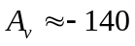, and we also calculated the input resistance and current gain of the circuit by calculating. Finally, we summed up the rules of common-Emitter:
1.The voltage gain is high and is negative
2.Low input resistance
3.High output resistance

For Common-Collector Amplifier：
Through simulation, we can get the common-collector's voltage gain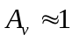, and we also calculate the input resistance and current gain of the circuit through calculation. Finally, we summed up the rules of common-Emitter:
1.Voltage gain is less than 1, approximately equal to 1
2.Low output resistance
3.High input resistance
4.Output is in the same direction as input

- Introduction

1.1 Introduction of transistor

A transistor is an electronic element in a circuit that controls a large amount of current or voltage with a small amount of voltage or current.The most common transistor is the bipolar junction transistor (BJT).Almost every modern electronic device has a transistor as its main active elements.

1.2 Frequency Response

Frequency Response of an amplifier or filter shows how the gain of the output responds to input signals at different frequencies.The frequency response of an electron or an electronic circuit allows us to see exactly what the output gain looks like (known as the magnitude response) and the phase (known as the phase response) changes at a particular single frequency, or over a whole range of different frequencies from 0Hz, (d.c.) to many thousands of mega-hertz, (MHz) depending upon the design characteristics of the circuit.[1]

1.3 The experiment content
We will first calculate based on the experimental data and simulate frequency response of a common emitter amplifier and a common collector amplifier.And we will observe the phenomenon of the frequency response of the common emitter (CE) and common collector (CC) BJT transistor amplifiers in the low to high frequency range (10 Hz to 300GHZ).

- Theory

2.1 Common-Emitter Amplifier

Through circuit analysis, we know that the by-pass capacitance  will short the resistor. By learning related knowledge, we also know common-emitter's output and input are opposite. I'm going to get a negative value of 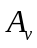 and get a large value of 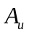. And the input resistance is low, the output resistance is high.
Similarly, we can estimate some values according to the learned knowledge:
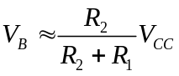
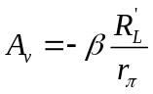
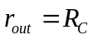

2.2 Common-Collector Amplifier

By learning, we know Common-Collector's . The input and output voltages are in the same direction and basically equal. We can use this property to check the correctness of the experiment. At the same time, the common-Collector circuit's input resistance is large, the output resistance is small.
We can also estimate some values based on what we have learned:

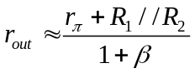

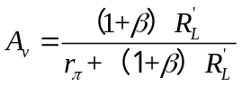

Circuit Design

3.1 common emitter amplifier

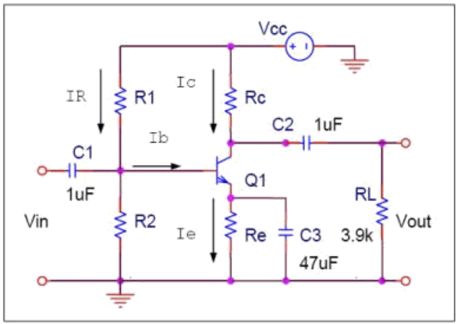
Figure 1: The common emitter amplifier[2]

In common emitter amplifier circuit ：
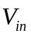： 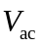= 0.02(V)
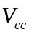：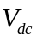=10（V）
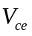==5（V）
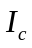= 5mA
After calculation:
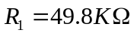
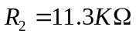
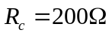
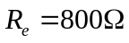
We need to measure 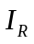、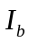、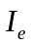 and get the figure for 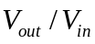based on the simulation.The magnitude of the current and the cause of the image are analyzed and calculated according to the theory.

3.2 common collector amplifier

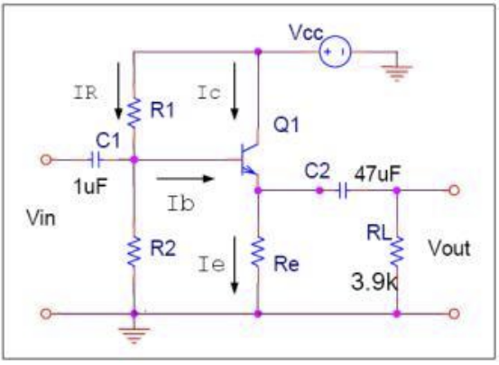
Figure 2: The common collector amplifier[2]

In common collector amplifier circuit ：
： = 0.02(V)
：=10（V）
==5（V）
= 5mA
After calculation:
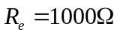
We need to measure 、、 and get the figure for based on the simulation.The magnitude of the current and the cause of the image are analyzed and calculated according to the theory.

Experimental Method

4.1 Transistor - BJT 2N3904
1) Resistor 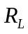=3.9 kΩ
2) Resistors Rc, Re , R1 and R2 according to prelab calculations
3) Capacitors 2 x 1μF, 1 x 47 μF.

4.2 Calculate the resistances

4.2.1 For Common-Emitter amplifier:

We know：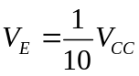、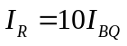、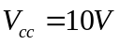、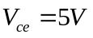、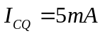

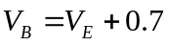
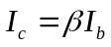
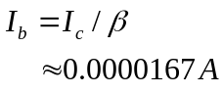
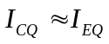
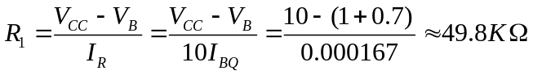
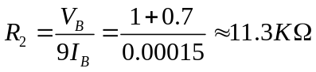
Through KVL:

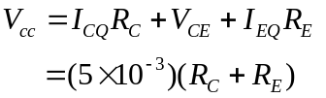
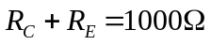
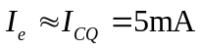
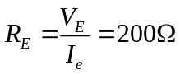
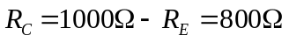

4.2.2 For Common-Collector Amplifier：

We know：、、、、

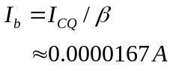
Through KVL:

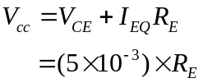
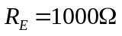

Results and Calculation

5.1 Common-Emitter amplifier

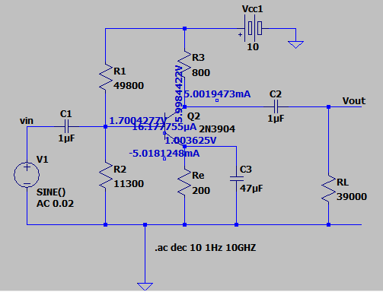

Figure 3：Circuit diagram simulated by LTspice software

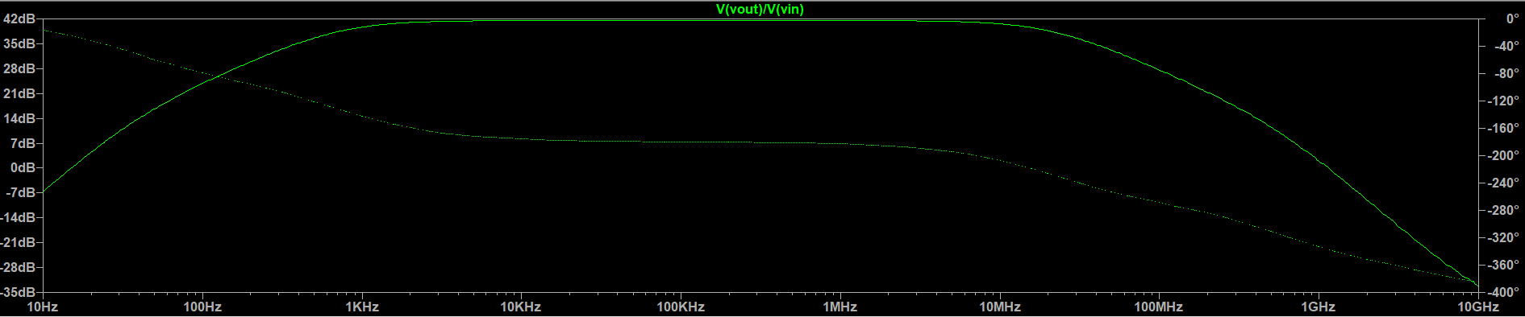

Figure 4: The analog image of
Through the analog image, we know that the 3dB point of this circuit is about 500 Hz.

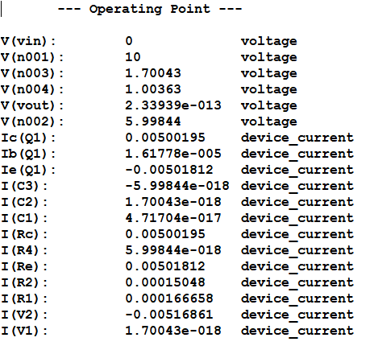
Figure 5:Simulation results

5.1.1 Calculate ：
We know:、、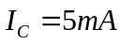、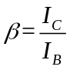

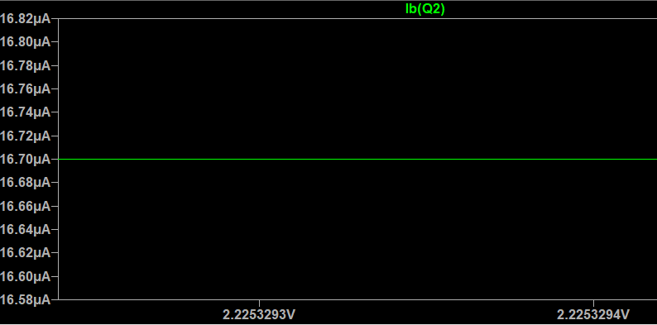

Figure 6：When , the analog of

Through the image, we found：

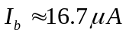
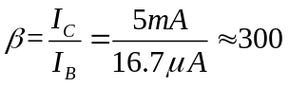

5.1.2 Calculate the voltage gain, the current gain, the input resistance
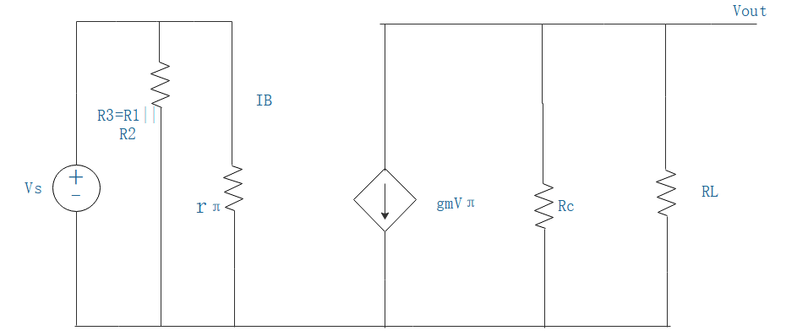
Figure 7：Small signal equivalent circuit

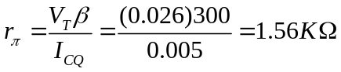
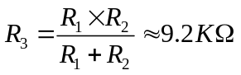
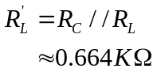
Input resistance:
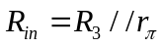
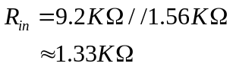
Output resistance:
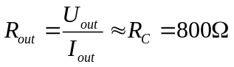
Voltage gain:
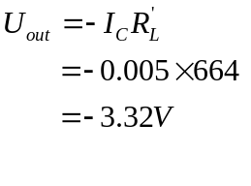
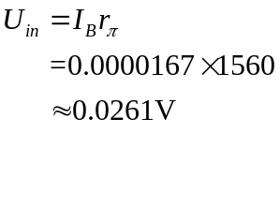
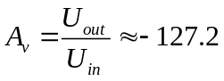
Current gain:
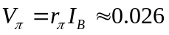
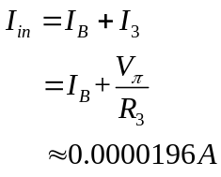
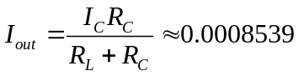
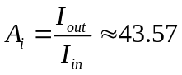

Therefore the results will be:

 | 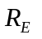 | 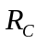 | 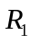 | 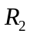 | voltage gain | current gain | input resistance | 3dB point
300 | 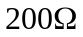 | 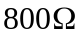 | 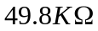 | 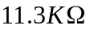 | -127.2 | 43.57 | 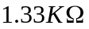 | 500Hz

The experimental data indicate that the common-emitter has a high but negative voltage gain, and the output resistance is high. After calculation of the simulated current, the value of is about 300. In addition, we also calculated the value of current gain. This circuit can amplify both voltage and current.

5.2 Common-Collector amplifier

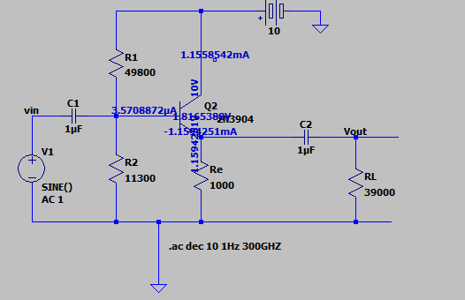

Figure 8：Circuit diagram simulated by Ltspice software

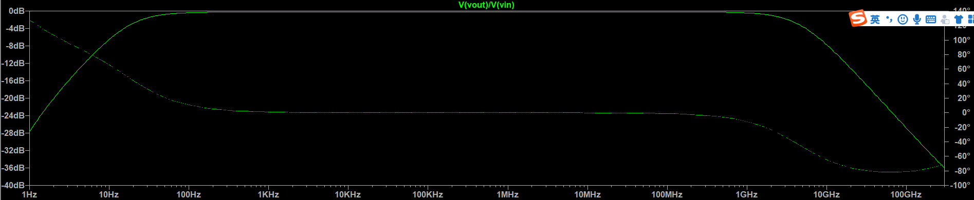

Figure 9: The analog image of

Through the analog image, we know that the 3dB point of this circuit is about 20Hz.
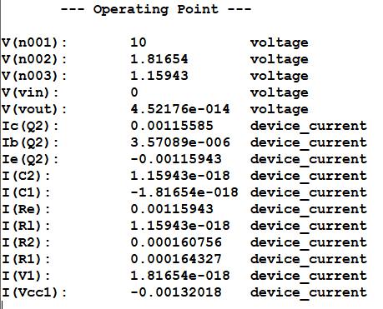
Figure 10:Simulation results

5.2.1 Calculate the voltage gain, the current gain, the input resistance

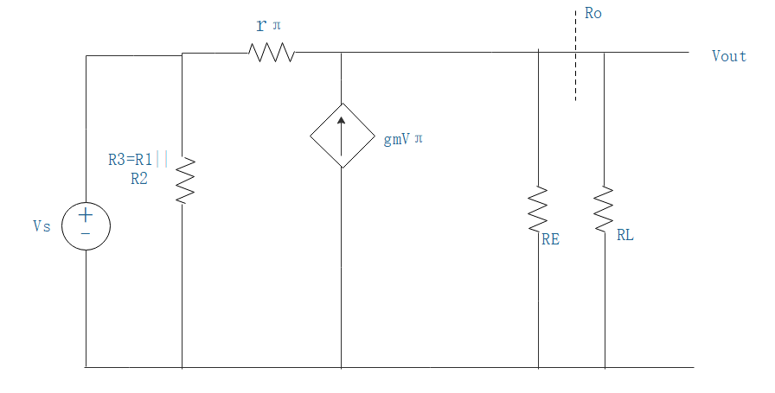

Figure 11：Small signal equivalent circuit

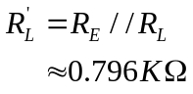
Input resistance:
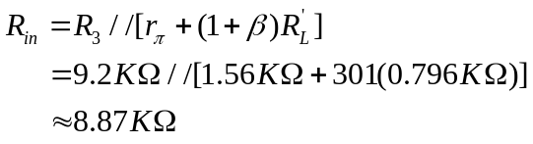
Output resistance:
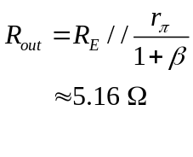
Voltage gain:
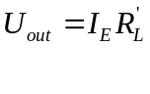
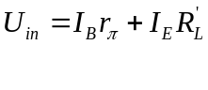
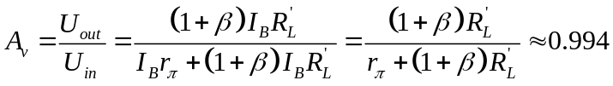
Current gain:

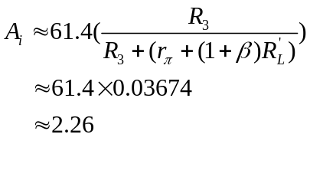
Therefore the results will be:

 |  |  |  | voltage gain | current gain | input resistance | Output resistance | 3dB point
300 | 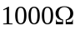 |  |  | 0.994 | 2.26 | 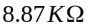 | 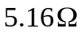 | 20Hz

It can be seen from the results that the common-collector circuit's voltage gain is about current gain is slightly larger. It means that common-collector can't enlarge the voltage, but only enlarge the current, and the Output resistance is relatively small.

Discussion

  - Common-Emitter Amplifier

Through the above calculation, we find that the voltage amplification rate of common-emitter is about -127.2. But after simulation, we found that the voltage gain is about -140. The error is within acceptable range and can be ignored.As 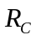 or goes up, goes up,too.The correctness of the simulation can be guaranteed by calculating the two methods. Conversely, we can also use simulations to verify the accuracy of the calculations.

Similarly, through calculation, we find common-Emitter has the following features:

1.The voltage gain is high and is negative
2.Low input resistance
3.High output resistance

The purpose of adding bypass capacitance is to reduce AC loss. In addition, by-pass capacitance will cause to become inoperative.

  - Common-Collector amplifier

Through calculation and simulation, we find that the common-Collector's voltage gain is basically 1, and the simulated value and the calculated value are basically the same within the range of error. Moreover, the common-Collector's input and output voltage in the same direction, and the output voltage follows the input. So, common-collector is also called the voltage Collector.The correctness of the simulation can be guaranteed by calculating the two methods. Conversely, we can also use simulations to verify the accuracy of the calculations.

Similarly, through calculation, we find that common-Collector Collector has the following features:

1.Voltage gain is less than 1, approximately equal to 1
2.Low output resistance
3.Output is in the same direction as input

Because common-collector has the above characteristics, the common-collector is more used in the first pole of multistage amplifier circuit. It can improve the input resistance and reduce the burden of signal source. And because the output resistance is low, common-collector can also be used to the end of multistage amplifier. It can reduce the output resistance and improve the load capacity.

7.Conclusion
Through simulation experiments, we have mastered the basic operation of LTspice and we can calculate the resistance and according to the simulation results. We studied the frequency response of the Common Emitter (CE) and common Collector (CC) BJT amplifiers in the low to high frequency range (10 Hz to 300GHZ). And it is simulated according to the circuit.

For Common-Emitter Amplifier：

We found common-Emitter's features are as follows:

1.The voltage gain is high and is negative
2.Low input resistance
3.High output resistance

We can use the characteristics of common-emitter to test the accuracy of the simulation result and the calculation result.

For Common-Collector amplifier:

We also find that common-Collector has the following features:

1.Voltage gain is less than 1, approximately equal to 1
2.Low output resistance
3.High input resistance
4.Output is in the same direction as input

It's because the common-Collector's input and output operate in the same direction, and the output voltage follows the input voltage. So, common-collector is also called the voltage Collector.Through the simulated experiment，we learned the frequency response of the common emitter (CE) and common collector (CC) BJT transistor amplifiers in the low to high frequency range (10 Hz to 300GHZ).

8.References
[1] Electronic Tutorials, “Frequency Response”.[Online]. Available:https://www.electronics-tutorials.ws/amplifier/frequency-response.html

[2] Department of Electrical and Electronic Engineering, “EEE109_Lab_%233_Spice_Amplifier_Lab Script.pdf”.[Online]. Available:https://learningmall.xjtlu.edu.cn/course/view.php?id=423

